DAILY ONLINE ACTIVITIES SUMMARY

|  |  |  |  |  |  |  |  |
| --- | --- | --- | --- | --- | --- | --- | --- |
| **Date:** | **27-06-2020** | | | | **Name:** | **Apoorva H P** | |
| **Sem & Sec** | **6th Sem ‘A’ Sec** | | | | **USN:** | **4AL17CS011** | |
| **Online Test Summary** | | | | | | | |
| **Subject** | | **Database Management System JDBC** | | | | | |
| **Max. Marks** | | **--** | | **Score** | | **--** | |
| **Certification Course Summary** | | | | | | | |
| **Course** | **Placement training** | | | | | | |
| **Certificate Provider** | | | **--** | **Duration** | | | **--** |
| **Coding Challenges** | | | | | | | |
| **Problem Statement: done** | | | | | | | |
| **Status: done** | | | | | | | |
| **Uploaded the report in Github** | | | | **yes** | | | |
| **If yes Repository name** | | | | <https://github.com/ashaapoorva/pre-placement-training> | | | |
| **Uploaded the report in slack** | | | | **yes** | | | |

**Class Snapshots:**

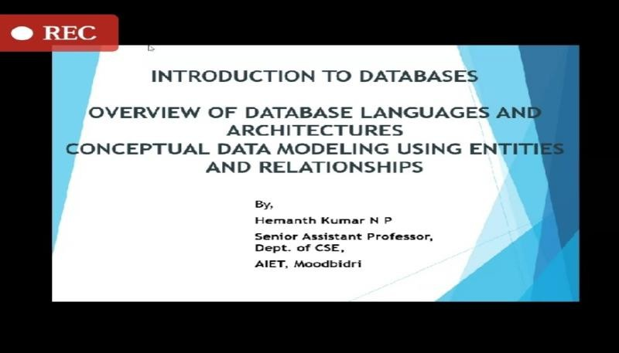

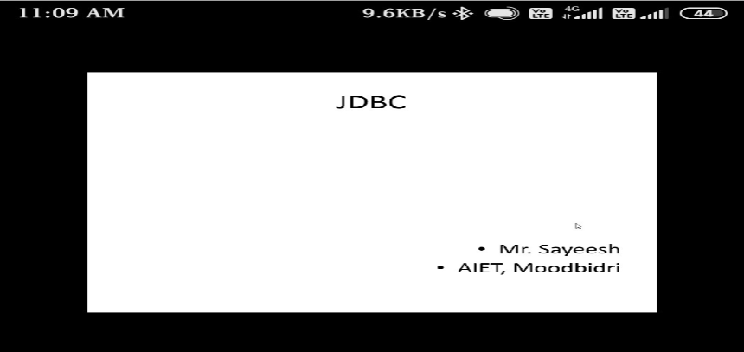

**Coding Challenges Details:**

Refer the github link for detail information : <https://github.com/ashaapoorva/pre-placement-training>